First Payroll of the Calendar Year

Presented by ESC, Region 14

_____1. Verify all data is displayed accurately for each pay date in 2021 in
Tables > Pay Dates.
- Double check School Year (2021)
- Pay Date, Begin Date, End Date, TRS Month, and TWC Quarter.
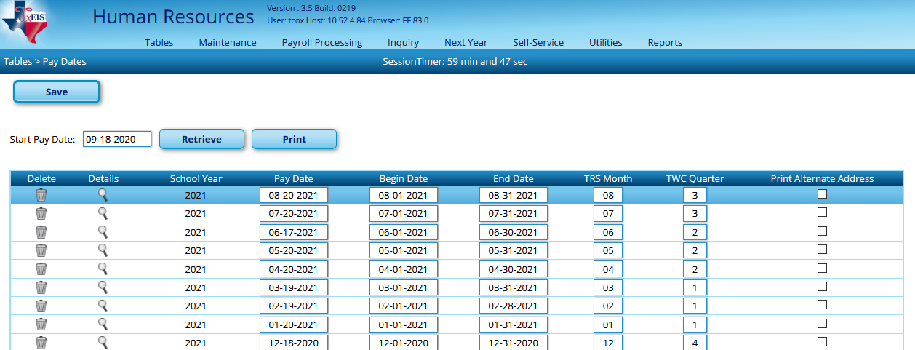
_____2. Update the tax tables for the new calendar year. The tax tables for January’s payroll are now updated on the document for Installing the new tax tables for 2021. The document and tables are on our TxEIS Web Page.
_____3. Verify pay information at the top of screen at
Payroll Processing > Run Payroll.
- Select your January Pay Date and Retrieve. This should match the pay information we verified in your Pay Date Table in step 1.
- Once verified Select Cancel.
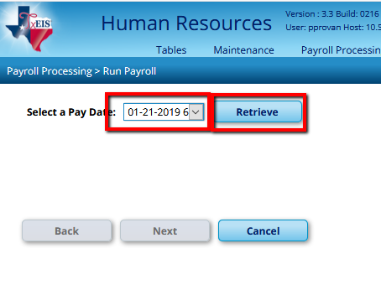
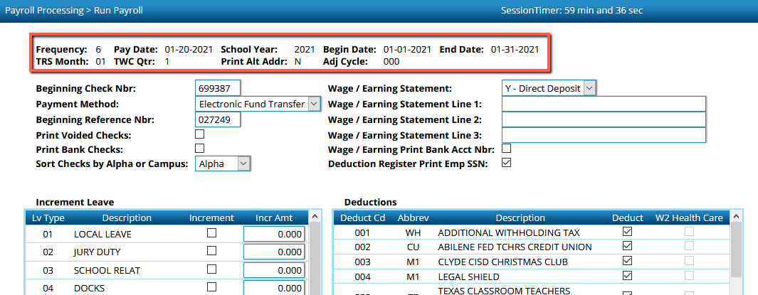

_____4. Process W-2s and give to your employees no later than January 31. The W-2 Processing Checklist is available on our website.
_____5. Process your Fourth Quarter 941 no later than January 31. The W-2 Processing Checklist will help you identify whether or not you need to make any adjustments to this submission.

